Kinzang Wangchuk

12190062

Frame1

<https://www.figma.com/file/e7OfVHRHMBt3s92QTghZ2p/GCIT_REVEMP_1?node-id=36%3A399>

Site Map

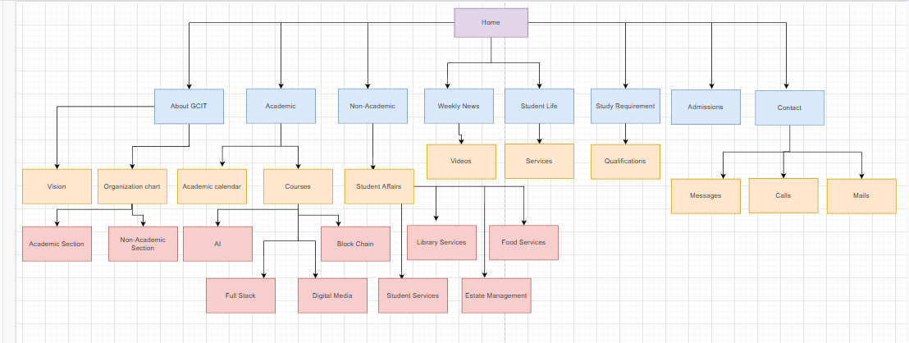

Problem Statement

The current website does not have Weekly News in the home navigation bar, so added navigation.

1. Home

|  |  |  |  |
| --- | --- | --- | --- |
| # | Item | Content | Functionality |
| 1 | College Logo | Gcit Logo | No functionality for college logo, it  is just an image.(Color code used for gcit logo are #FFA500 and #90EE90) |
| 2 | RUB Logo | RUB Logo | No functionality as such for RUB logo, it is just an image. |
| 3 | About GCIT | It contain hero banner and it contain short description of colleges. It also describes about our college vision. Color code used are #fffff and #00000 | Clicking upon About GCIT it navigate to the page where it display  the image of college and its description and also it display vision of our college. |
| 4 | Academic | It contains hero banner of academic calendar and courses. Color code used are #fffff and #00000.(font size used are h1 for sub header and h2 it’s description. | Clicking upon Academic it navigate to the page where it display and academic calendar and courses and it’s description. |
| 5 | Non-Academic | It includes hero banner and they are the coordinator. They how they provide helping hands to the student. Color code used are #fffff and #00000.(font size used are h1 for sub header and h2 it’s description. | When we click on the Non-Academic it diverse to the page where it display about student affairs  And services provided to the student and all the faculty in the colleges. |
| 6 | Weekly News | It display the videos of various collected news from national, international and local. . Color code used are #fffff and #00000. (Font size used are h1 for sub header and h2 it’s description. | Clicking upon weekly news it navigate to the page where it contain videos and it’s description. |
| 7 | Student Life | It includes the services provided to students. | Clicking upon student life, it navigate page where it provided services to student. |
| 8 | Study Requirements | It is just description. Color code used are #fffff and #00000.(font size used are h1 for sub header and h2 it’s description | Clicking upon Study Requirement it navigate to the page where it contain its description. |
| 9 | Admission | It display hero banner. Color code used is #00000. | Clicking upon Admission it navigate to the page where it display how many student were intake for the particular courses. |
| 10 | Contact | It display hero banner.  Color code used are #fffff and #00000. (Font size used are h1 for sub header and h2 it’s description. | Clicking upon contact it display an options either contact through calls, mail and other apps. |

1. About GCIT

|  |  |  |  |
| --- | --- | --- | --- |
| # | Item | Content | Functionality |
|  | Navigation Bar | It contain all the navigation item as I mentioned in home page | Functionality is same as I mentioned in the home page. |
| 25 | Image1 | It contain the image of gcit College. | There is a hovering effect(Color code used is #90EE90) |
| 26 | Image2 | It contain image of time | There is a hovering effect(Color code used is #0000FF) |
| 27 | Footer section | It contain all links | Write all the necessary links |

2. Academic Section

|  |  |  |  |
| --- | --- | --- | --- |
| # | Item | content | Functionality |
| 28 | Organization chart | It includes head of the colleges and then other faculty members | There is no special functionality |
| 29 | Footer section | It contain all links | Write all the necessary links |

3. Non-Academic Section

|  |  |  |  |
| --- | --- | --- | --- |
| # | Item | content | Functionality |
| 30 | Organization chart | It includes head of the colleges and then other faculty members | There is no special functionality |
| 31 | Footer section | It contain all links | Write all the necessary links |

4. Academic Calendar

|  |  |  |  |
| --- | --- | --- | --- |
| # | Item | content | Functionality |
| 32 | Image | It contain image of calendar | There is no special functionality |
|  | Description | It includes academic session in the particular year. Color code used are #fffff and #00000. | There is no special functionality |
| 33 | Footer section | It contain all links | Write all the necessary links |

5. Courses

|  |  |  |  |
| --- | --- | --- | --- |
| # | Item | content | Functionality |
| 34-35 | Bachelor of Digital Media & Development | It contain image of related module. | There is no special functionality |
| 36-37 | Bachelor Of Computer Science (AI Development & Data Science) | It contain image of related module. | There is no special functionality |
| 38-39 | Bachelor Of Computer Science (Full Stack Development) | It contain image of related module. | There is no special functionality |
| 40 | Bachelor Of Computer Science (Block chain Development) | It contain image of related module. | There is no special functionality |
|  | Description | It includes description of particular module. Color code used are #fffff and #00000. | There is no special functionality |
| 41 | Footer section | It contain all links | Write all the necessary links |

6. Student Affairs

|  |  |  |  |
| --- | --- | --- | --- |
| # | Item | content | Functionality |
| 42 | Image | It contain image | There is no special functionality |
| 43-44-45-46-47 | Organization chart | It contain the members of student affairs. Color code used are #fffff and #00000. | There is no special functionality |
| 48 | Footer section | It contain all links | Write all the necessary links |

7. Student services

|  |  |  |  |
| --- | --- | --- | --- |
| # | Item | content | Functionality |
|  | Description | It contain how to provide services to the students. Color code used are #fffff and #00000. | There is no special functionality |
| 49-50-51 | Organization chart | It contain the members of student services. Color code used are #fffff and #00000. | There is no special functionality |
| 52 | Footer section | It contain all links | Write all the necessary links |

8. Library services

|  |  |  |  |
| --- | --- | --- | --- |
| # | Item | content | Functionality |
|  | Description | It contain how to provide services to the students. Color code used are #fffff and #00000. | There is no special functionality |
| 53-54-55 | Organization chart | It contain the members of student services. Color code used are #fffff and #00000. | There is no special functionality |
| 56 | Footer section | It contain all links | Write all the necessary links |

8. Food services

|  |  |  |  |
| --- | --- | --- | --- |
| # | Item | content | Functionality |
|  | Description | It contain how to provide services to the students. Color code used are #fffff and #00000. | There is no special functionality |
| 57-58-59 | Organization chart | It contain the members of student services. Color code used are #fffff and #00000. | There is no special functionality |
| 60 | Footer section | It contain all links | Write all the necessary links |

10. Estate Management (EM)

|  |  |  |  |
| --- | --- | --- | --- |
| # | Item | content | Functionality |
|  | Description | It contain how to provide services to the students. Color code used are #fffff and #00000. | There is no special functionality |
| 61-62-63 | Organization chart | It contain the members of student services. Color code used are #fffff and #00000. | There is no special functionality |
| 64 | Footer section | It contain all links | Write all the necessary links |

11. Weekly News

|  |  |  |  |
| --- | --- | --- | --- |
| # | Item | content | Functionality |
| 65 | Video button | It contains video from national international and local. | There is no special functionality |
|  | Description | It includes the news from various corner. Color code used are #fffff and #00000. | There is no special functionality |
| 66 | Footer section | It contain all links | Write all the necessary links |

12. Study Requirement

|  |  |  |  |
| --- | --- | --- | --- |
| # | Item | content | Functionality |
|  | Description | It includes qualification and how student must get through to the particular course. Color code used are #fffff and #00000. | There is no special functionality |
| 67 | Footer section | It contain all links | Write all the necessary links |

13. Admission

|  |  |  |  |
| --- | --- | --- | --- |
| # | Item | content | Functionality |
| 68 | Image1 | It includes how much student should be taken for the particular year. | There is no special functionality |
| 69 | Image2 | It includes Admission For Bachelor Of Digital Media & Development | There is no special functionality |
| 70 | Image3 | Admission For Bachelor Of Computer Science | There is no special functionality |
| 71 | Footer section | It contain all links | Write all the necessary links |

14. Contact

|  |  |  |  |
| --- | --- | --- | --- |
| # | Item | content | Functionality |
| 72-73-74-75 | Image1 | It includes following apps to interact with us. | There is no special functionality |
| 76 | Footer section | It contain all links | Write all the necessary links |

Reference